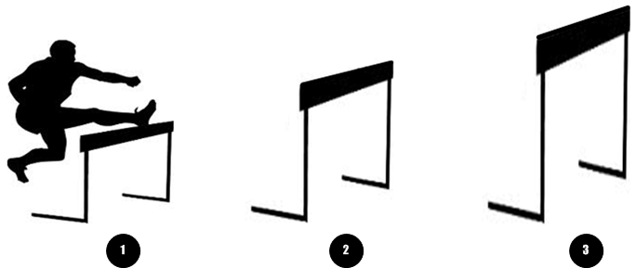

The Hurdles of Recovery

What are some of those challenges that we must get over in order to make progress in our life?

What are some of those processes that we must begin to put energy into so we can have a better tomorrow?

We look into some of the arguments that are used by people who resist recovery….and their desire to stay stupid…

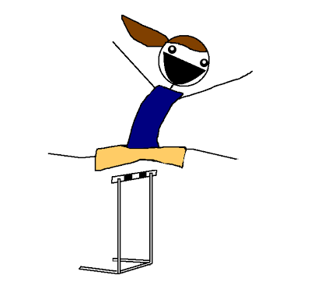

This is a manual that can lead to understanding how to make a better life by getting into and through a recovery process that defines and supports doing what is most important in life……

©Copyright 2015 Steve Scaggs

Recovery means that I am doing those things that are most important in life.
A hurdle is defined as something I must get over so that I can progress.

Unit One

- Guilt – I am the worst of the worst. Just ask anyone.
---I remember how bad I have been. –and- There are witnesses.
- Condemnation – the voices around me only hurt me…
---Voices, vices, --- or- vises?
- Numb to the needs – what I need does not matter anyway…..
---I gave up wanting a better life a long time ago. So many people hate me.

Unit two

- Unclear intentions – there is no way to know what will help me….
---nothing in my life has ever worked out right – so – let’s party!

- Distorted judgements- I only hear rejection. Shut up or I will shut you out!

- Unforgiving – I don’t need you in my life, anyway.

- Fame and no future – everyone knows my name. Fame is my game.

Unit three

- False attentions – pretending to know the facts – There is no truth.

- Dangerous intentions – I can mix my remedies with my festivities.
Bad habits can be thought of as good company
- Nobody knows the trouble I’ve seen – my imagination is in control.

- I am in control of my future – what happened last time will not happen again.

Unit four

- If you haven’t been where I am at – you can’t help me.

- I will work on that tomorrow- the pain of my past hurts today.

- I can’t learn anything new – I have a learning disability.

- I like being alone – the pressures of life are not important if I am left alone.

Unit One: Notes

- Guilt – I am the worst of the worst. Just ask anyone.
---I remember how bad I have been. –and- There are witnesses.

When do I know when I have done something wrong?

Is doing a wrong thing self-taught or taught by others?

Does being wrong about life “feel” bad?

What are the five worst things I have done in my life?

List the names of the people who know these things?

- Condemnation – the voices around me only hurt me…
---Voices, vices, --- or- vises?

Is condemnation self-inflicted?

Do I give other people my ear for advice about right and wrong? Which people?

If I do the same things wrong over and over, is the wrong distorted? Larger or smaller?

Who tells me the most often that I have done a lot of things wrong?

- Numb to the needs – what I need does not matter anyway…..
---I gave up wanting a better life a long time ago. So many people hate me.

What are the ten things I want most out of life? Today or Tomorrow? Sooner or later?

Have I ever promised someone else that I would do something just for them? to help them, or to them help me?

What three things do I give up most often in order to help others? What are the three things in life I need the most help with?

In all honesty, is there anyone that I borderline hate? Who do I love the most in order of importance(list at least 5 names)?

Unit Two Notes:

4 Unclear intentions-- there is no way to know what will help me. Nothing in my life has ever worked out right. So – Let’s party!!!

The condition I have put myself into is genetic – My parents created a mess and I grew up in that mess – so – I am a mess.

There is no way to change my past and no way for me to get rid of what my past did to me so—there is no help for me.

If you don’t do things for me then how will my life get better?

Because my life will never get better, I will do what feels good….. I will party.

P – play. I will never take life seriously. I can live my life like there is no consequence to anything that I do.

A – act. I will imagine that no one cares about me. I will act like I am worthless and live in self destruction.

R – rebel. I will brand myself as a misfit. A misfit will never belong so I will live in continual rebellion against stability. I will resist any effort that will make me responsible for my actions and therefore I will never be held accountable for anything….

T – take. I will live life on the take never on the give. Whatever is yours should be mine, without any effort on my part. I will take what I want from you. I will never be able to receive any second chance, any opportunity for better, any help to learn and absolutely I will never receive any lift from effort that would create achievement in my life.

Y – yell. I will create such a repulsive lifestyle that no one will want to be near me. That way I can prove that I am just a mess, a mistake, and a loser. I will justify my actions that will destroy me and keep others afraid of me.
5 Distorted judgements. I only hear rejection. Shut up or I will shut you out!

To judge someone means to separate them from any agreements that improve quality of life.

To condemn someone means to put a barricade in place that will not allow anyone to get close enough to you to change your behaviors.

If that repulses you, then, I will consider that to be rejection. I will never have to correct my behavior because you are the one that has rejected me. You need to change.

If you do not agree with me then I will shut you out of my life. If you argue with me I will take action to shut you up. You have to believe what I believe to be true, or else!

6- Unforgiving – I don’t need you in my life, anyway.

The clear path to forgiving someone is full of major distractions

I don’t need my life to be full of complications.

There is no place for letting you get into my life….. or is it getting you out of my life?

I would not have the same life if I let you off the hook…

7- Fame and no future – everyone knows my name. Fame is my game.

The best place for me to go to is where everyone knows my name – or at least everyone knows my dirt….not my heart- just my dirt

If I hang out with this crowd long enough…. I will not make any effort to “fix” my issues I just have to get my “fix”.

The thing that I hate the most about other people is the way that they are such liars…they say one thing and do another…

Besides….no one is ever going to get close enough to me to figure out what my needs are. I will make sure they all know what I think about them…. they will tell others to stay away from me. --- I win.

Unit Three Notes

8- False intentions ---pretending to know the facts - There is no truth.

When I go to meetings I already know all the answers, because I am in control of my life.

I never answer any questions about my life. I only tell all about what I have done.

People in group meetings are such fakers anyway. People turn right around go out the door and continue doing their stupid stuff. I never hang out with flaky fake people.

And…there is nothing that is discussed at group meetings or in group classes that deals with my stuff anyway. Someone always controls the meeting anyway.

That is why I never go to any group meetings anyway. People are so stupid. They can’t handle the truth about their issues. Especially if the class leader doesn’t know my issues.

9. Dangerous intentions - I can mix my remedies with my festivities.
Bad habits can be thought of as good company.

I know how much I need pain medicine. Errrr…. How much I need my pain remedy…

The best place for me to be when I hurt is at some festivity. Some place where people are fun to be with.

And if I do get ripped….. they know about it and don’t judge me.

There are better places for me to be in order to get clean, but nobody understands my issues like my friends. They accept me.

And… I help them with their issues too. We all have the same issues.(bad habits). So it is the best place for me to be.

10 Nobody knows the trouble I’ve seen! - My imagination is in control…

What is the left side – right side of my brain function?

If no one recognizes my disorders then I guess what I have must be genetic.

So, if my troubles are genetic then I am going to have to live with trouble and never know what life under control will be.

I can only use my imagination to assign values to what is happening in my life.

If there is no answer for what is wrong with me, then I will wander through life in and out of homes, classes, the street, and even eventually walk near death (the wild side).

11 I am in control of my future !! What happened the last time I let myself get into a commitment? THAT will never happen again.

List the 10 worst troubles you have ever been in.

What are 10 things that are horrible memories based on your past history of getting into uncomfortable situations and how you were hurt by others.

What are 5 things you will never let anyone do to you again?

What was the best commitment you ever let yourself get into?

If you could do 5 things over again what would they be?

Unit four Notes

12 If you have never been where I am at--- you cannot help me!

What are the 5 most important things you have learned about how to have value for yourself?

When did you learn how to tie your shoes?

When did you learn how to read and write?

On a scale of 0 --- 10 0 being not able and 10 meaning really good ----
How well can you spell?
How well do you read?

Do you think that a person has to have the exact same experiences in life in order to understand how life is when something in life does not work out with good results?

Is learning how to solve problems subject to how to learn from experiencing the same failures, or how many times failure occurs?

Who is the best teacher – someone who fails at problem solving over and over or someone who has learned how to solve problems no matter what they are about?

13 I will work on “that” tomorrow – the pain of my past hurts today.

If I get out of bed today, I have to do something. I don’t know what to do about yesterday.

If I go back to bed, I can get just a few more minutes of not dealing with today.

I wonder what other people who are like me do about their pain?

Everyone says that I will get over this crisis if I just live one day at a time.

I just have to focus of myself and not worry about anyone else but me. – Now.

14. I can’t learn anything new. I have a learning disability.

I have had an evaluation that says that I have a learning disability. It is from when I was 6 years old. I was diagnosed again when I was 13. I still have a learning disability.

What are the best 10 things you learned how to do for yourself?

What are the best 10 things you learned how to do for others?

If you could have the perfect job- what would that be?

What is the best thing you like to do with your time?

What is the best thing you like to do with money?

What is the best thing you like to do with other people?

15 I like being alone. The pressures of life are not important if I am left alone.

Where does a train go without railroad tracks?

The final thing I have to say about that is “leave me alone”

But one more thing, like I said 100 times before…..I don’t need anyone.

No really, I don’t want anyone to know where I am at.

The only thing …..left for me to do …….. this is the only thing left for me to do.

